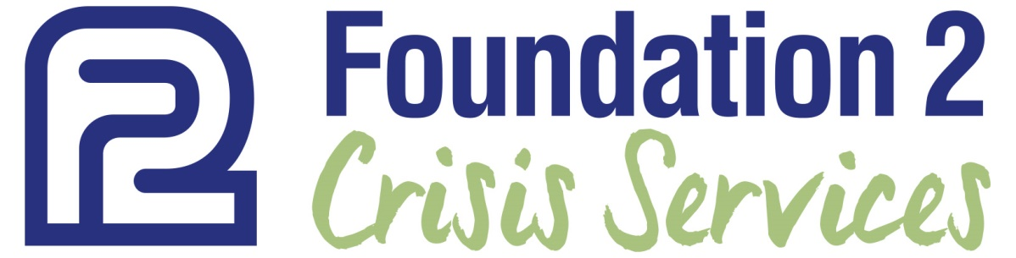
Beginning May 28th, Foundation 2 Mobile Crisis Outreach (MCO) will be available, at no cost to individuals located in Scott and Cedar County; 24 hours a day, 7 days a week by calling The Eastern Region Crisis Line at:
844-430-0375
Experiencing a Crisis?
When a service provider, medical professional, employer, family member, friend or individual believes a situation would benefit from on-site crisis intervention, they can call 1-844-430-0375 to discuss Mobile Crisis Outreach with Foundation 2 staff.

What to Expect?
Mobile Crisis Outreach is confidential. We know that reaching out isn’t always easy—it’s OK to feel nervous or even uncomfortable at first.

Our counselors approach each dispatch with an open mind, and with respect to you and your situation. We’re here to listen, give you information, and explore safe options to help you in your time of crisis.

We give you control of the conversation, but we understand that sometimes it’s hard to put your feelings into words. If you’re unsure how to start the conversation, we can begin by asking you a few questions about your situation. If you don’t know what to say, that’s OK. There is no cost for utilizing MCO.

How does MCO Work?
A team of counselors will be dispatched, usually arriving on site within 60 minutes to:
- Assess the situation
- Attempt to stabilize and diffuse the crisis
- Provide counseling as needed
- Provide referrals to other Foundation 2 or community resources (follow-up 24 hours later by a case worker)

Questions?
Go to www.foundation2.org
Call or Email: Kelly Herd, MCO Program Coordinator 309-429-2671 kherd@foundation2.org

